DELIVERY DATE & TIME: _________________________

NAME: __________________________________________________________________ DATE: _________________

ADDRESS: _______________________________________________________________________________________

CITY: ________________________________ STATE: _____________ZIP CODE: ______________________________

PHONE: ______________________EMAIL: _____________________________________________________________

BIRTH DATE: ______________ GENDER: _______ HEIGHT: _______ WEIGHT: _______ GOAL WEIGHT: _________

OCCUPATION: ___________________________EXERCISE LEVEL: ______________STRESS LEVEL: ___________

MEDICATIONS (PRESCRIBED, OTC & VITAMINS): ______________________________________________________________

________________________________________________________________________________________________

FOOD ALLERGIES: _______________________________________________________________________________

ILLNESS CONCERNS: ____________________________________________________________________________

PRODUCT SELECTION
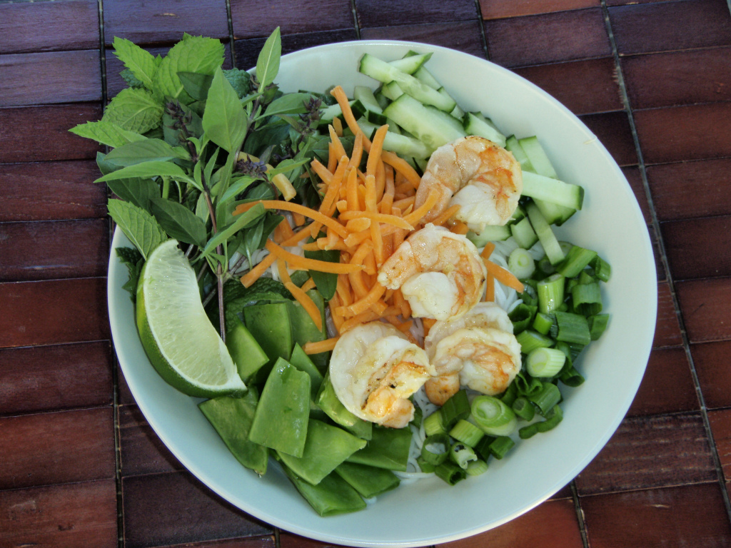

- SOUP FULL DETOX
- 90DAY PLAN (JUICE)
- 90DAY PLAN W/O JUICE
- PC MINI SERVICE
- HEALTH COACHING PACK
- VITAMIN PACK
- FAST TRACK 2x2 DETOX
- GLADIATOR DETOX
- ROYAL JUICE ONLY
- COOKING & EATING NATTY PACK
- HEALTH EATING & COOKING 101 BINDER

MEAL PLANNING

- 1WEEK MEAL PLNG $15.99 ___ 30DAY MEAL PLNG $35.99

ROYAL HEALING SMOOTHIES
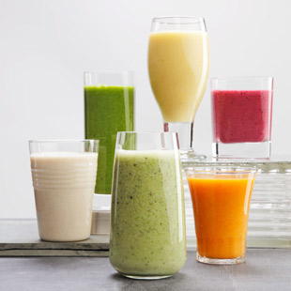
64oz. $46.99 32oz $23.99 16oz $12.99
Flavor | Size | Quantity | Total
SUBTOTAL: $_______.___ +SHIPPING & TAX: $_______.___ ORDER TOTAL: $_____.____

PAYMENT METHOD: CASH_____ MONEY ORDER# ___________________PAYPAL______VISA/MASTERCARD______
PAYMENT PLAN: WEEKLY___________ BIWEEKLY____________ MONTHLY_____________ LUMP_________________

CLIENT SIGNATURE__________________________________ DATE___________________

NQC STAFF SIGNATURE__________________________________ DATE________________

Meal Planning Questionnaire

Are there any dietary restrictions? Diabetic ____ Cardiac Condition ____ Gastro Condition____
High Blood Pressure ____ Light Salt ____ No Salt ____ Low Fat ____ No Fat ____
Low Carbohydrates ____ Other: ______________________________________________

On average how much or how many meals to you consume daily? ____________________

Are you sensitive to any of the following? Garlic ____ Onions ____ Mushrooms ____
Bell Peppers ____ Tomatoes ____ Other Sensitivities: ____________________________

Spicy Food Scale: Bland ____Mild ____Medium ____Hot ___Extremely Hot ____

What Fruits and Vegetables do you dislike?
____________________________________________________________________________
____________________________________________________________________________

What Fruits and Vegetables do you like?
___________________________________________________________________________
___________________________________________________________________________

What restaurants do you regularly frequent? _____________________________________
____________________________________________________________________________

What Cuisines do you enjoy? Mexican ____ Italian ____ French ____ Thai ____ Soul_____
Chinese ____ Other: ______________________________________________________

How many times per week do you eat the following?
Beef ____ Pork ____ Chicken ____ Turkey ____ Fish/Seafood ____

When you eat Poultry do you prefer? Dark Meat ____ White Meat ____ Both ____
Fish/Seafood Favorites: ______________________________________________________________________________
Overall Favorite Dishes: ______________________________________________________________________________
Do you eat Soups as a main dish? Yes ___ No ___ Salads? Yes ___ No ___

Favorite Salad Greens: __________________________________________________________
Do you like Cherry Tomatoes? Yes ___ No ___
Do you eat Pasta as an entrée? Yes ___ No ___
Ravioli ____ Tortellini ____ Pasta with: Marinara Sauce ____ Pesto Sce ____Meat Sce ____ Alfredo Sce ____

Do you eat Vegetarian/Vegan entrées? Yes ___ No ___ Do you eat Cheeses? Yes ___ No ___
Dried Products: Grains _____ Beans _____ Bulgur _____ Nuts _____
Do you like Baked Goods? Cookies _____ Brownies _____ Pies _____ Cakes _____
How many days a week do you grocery shop? _____ Where? ______________________________________
OFFICE USE ONLY
CLIENT #____________ EVAL DATE: __________ CONTRACT TERM__________ NQ TEAM________
PAYMENT PLAN_______________ START DATE______________ CONF SENT_____________

